9 WebDriver Set Sampler: Script



This section will guide you:

* To work with WebDriver Set Sampler - Script.

**Development Environment:**

* Apache JMeter 5.1.1 Version
* OpenJDK Runtime Environment 11.0.2

This guide has four sub-sections, namely:

1.9.1 Installing JMeter Plugins Manager

1.9.2 Adding the WebDriver Set Sampler

1.9.3 Running the scripts in WebDriver Set Sampler

1.9.4 Pushing the code to GitHub repositories

**Step 1.9.1:** Installing JMeter Plugins Manager

* Go to Google and search for ‘JMeter Plugins Manager.’
* Download the Plugin Manager jar file.
* Unzip the jar file and add that jar file to the lib folder.

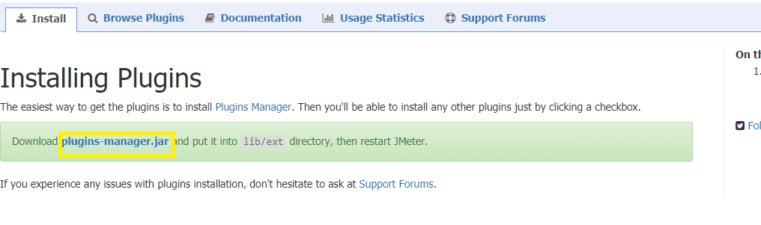

* Restart JMeter.

**Step 1.9.2:**  Adding the WebDriver Set Sampler

* Right click on Test Plan.
* Click on Add -> Thread Users -> Thread Group.

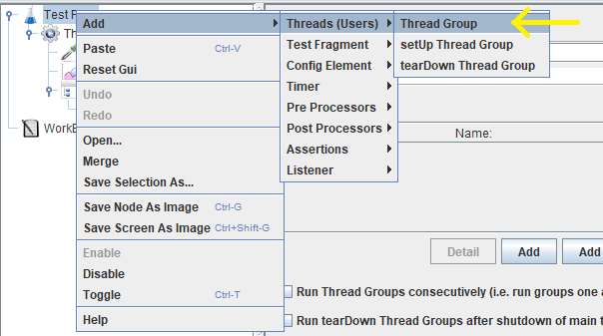

* Right click on Thread Group.
* Click on Add -> Config Element -> jp@gc - Firefox driver Config.

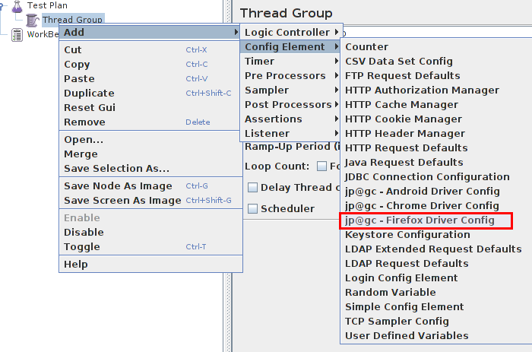

* Add Config Element -> HTTP Cookie Manager.
* Select Config Element -> jp@gc - Firefox Driver Config.
* Select Sampler ->jp@gc -Web Driver Sampler.
* Select Listener -> View Results Tree.

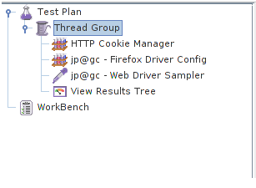

**Step 1.9.3:** Running the scripts in WebDriver Set Sampler

* Open the WebDriver Sampler.
* Run the script.

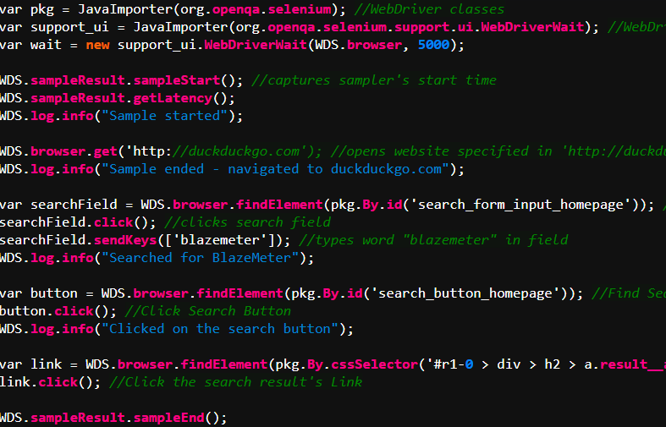

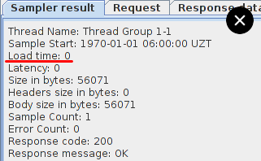

**Step 1.9.4:**  Pushing the code to GitHub repositories

Open your command prompt and navigate to the folder where you have created your files.

cd <folder path>

Initialize your repository using the following command:

git init

Add all the files to your git repository using the following command:

git add . 

Commit the changes using the following command:

git commit . -m “Changes have been committed.”

Push the files to the folder you initially created using the following command:

git push -u origin master